**Js day 5**

**1. Date Object**

1. Ask user to enters the date in prompt, then alert the Day name (Saturday, Sunday,…) of the given date.
2. Show prompt that ask user to enter his birth date and tell user to enter the date in the following format (DD – MM – YYYY) ex. 22–01–1999, and then create function that take user input as a parameter and ensure that the string is entered in this format (that user entered string is 10 characters and contains (-) after the second character and after fifth character).[Don't use RegExp, use string functions].
   1. If the user input was correct: make the function create new date object, and initialize it with Day, Month, year values (using date constructor: Date(y,m,d)) and then show alert to the user with the date in date string format.
   2. If user input wasn't correct, show alert saying "Wong Date Format".
   3. Create button “show date” that calls the function.

**2. Math Object**

2.1 Write a script that ask the user to Enter the value of a circle’s radius in order to calculate its area as shown in fig.

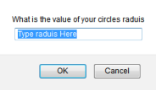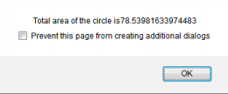

2.2 Enter another value to calculate its square root and alert the result as shown in fig.

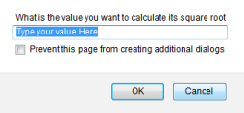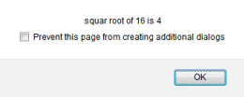

1. **Array Object**
   * + 1. Create array that contain some tips about JavaScript (Array of 10 strings, each string is tip about JS), and show random tip for the user each time he opens the page "Tip of the day".

2. Fill an array of 3 elements from the user, and apply each of the following mathematical operations on it (+, *, /). Format the output as shown in Fig.

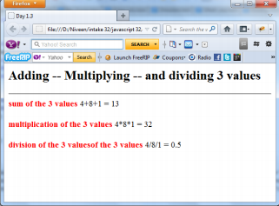

1. Write a function that takes any number of parameters and returns them reversed using array’s reverse function.
2. **events**
   * + 1. Make a button that display the current date and time in local format on the page.
       2. Make a buttons on a page when user clicks it, ask him to enter math expression (Ex. 3+4*5/10*8), and then pass this expression (user input) to a function that take one parameter and execute this expression and then show the result of this expression for the user in an alert in that format: (You entered: 3+4*5, and the result is: 23).